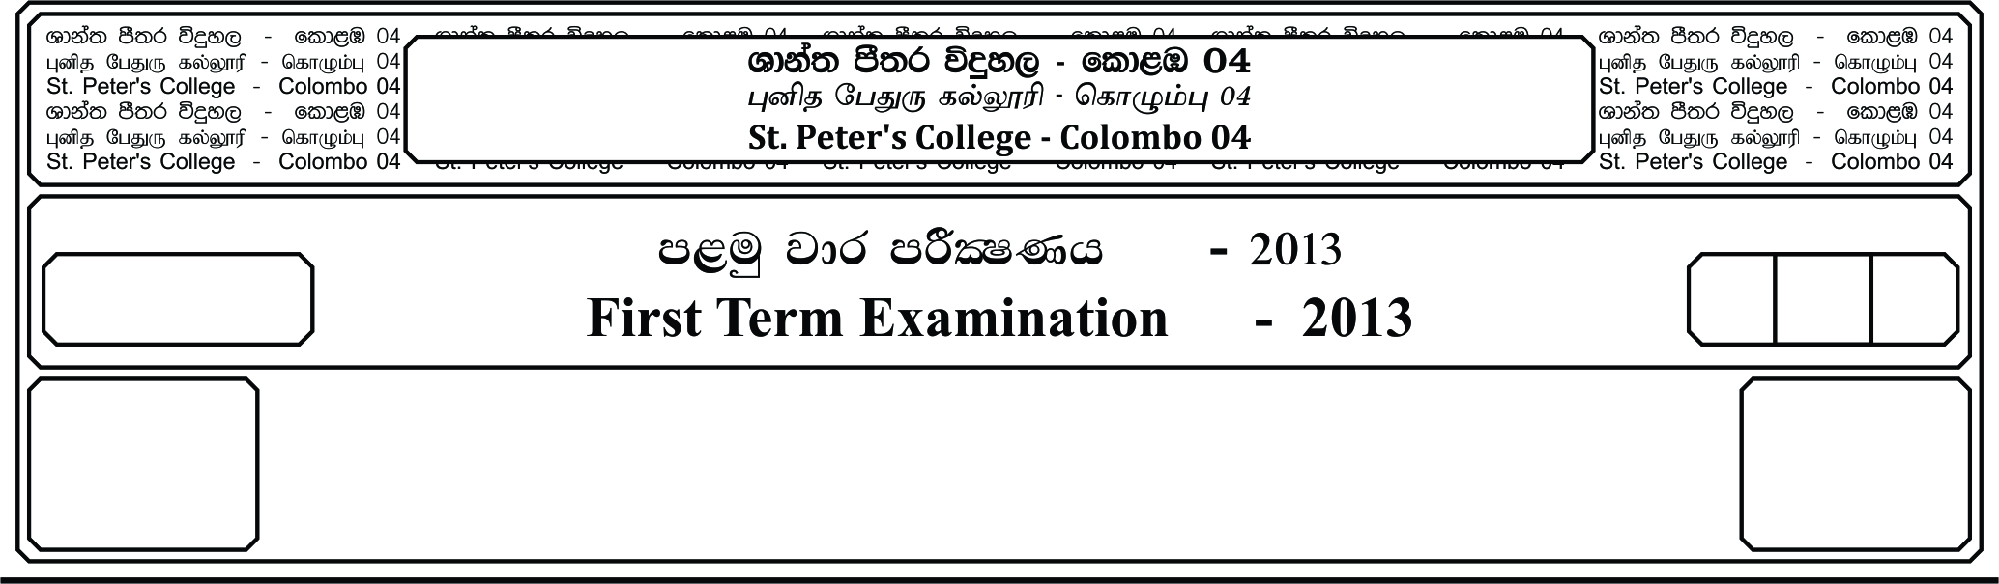

13 fY%aKsh

GRADE 13

E

meh

Hour

II

**m<uq jdr mÍCIKh - 2021**

**First Term Examination - 2021**

l%sia;shdks O¾uh - »»

**CHRISTIANITY – II**

**Choose 02 questions from the Part I and 03 from the Part II and answer altogether 05 questions.**

01. i. Write 04 names given for the land of the chosen race. **(02 Marks)**

ii. Write the name given for the area that begins from the Persian Bay and margined towards the Mediterranean coast. **(04 Marks)**

iii. Write the boundaries of ancient Palestine. **(06 Marks)**

iv. Write 04 Geographical disparity natural areas. **(04 Marks)**

v. Write 03 major historical civilizations in Geographical background of Palestine.

**(04 Marks)**

02. i. Mention 02 points about the synoptic Gospels problems.

ii. Describe 02 similarities apparent in the synoptic Gospels with examples.

iii. Describe 03 dissimilarities between the synoptic Gospels and Gospel of John with examples.

iv. Mention 04 acts done by St. Paul in the mission of spreading the religion and explain with examples, four activities that you can perform in order to continue the same.

v. Write the first Missionary journey of St. Paul.

03. i. After Jesus was baptized by John in the river Jordan, and as soon as Jesus came up out of the water he saw heaven opened. Describe in 04 points about the above statement.

ii. How will you describe the Apostle St. John.

iii. Write 02 responsibilities of a Christian.

iv. Describe 03 persecutions faced by Christians during the period of Emperor Valerian.

v. Write 02 similarities in Synoptic Gospels.

04. i. Describe about part II the creations of God explain in the Holy Bible of the 1st 5 days.

ii. What are the reasons for the people to get disappoint with the king Solomon. Give 03 statements.

05. i. Name the major prophets of Israel.

ii. Explain 05 qualities you possess in order to be a prophet in your society.

06. i. Write in order the Sermon on the Mount.

ii. Explain how you live in the society taking in to consideration the above sayings of Jesus.

07. i. Name main 02 features in the rituals of passion.

ii. Explain how do you prepare yourself to take part in the passion play organized by the youth.

08. i. Who took the leadership in conducting the council of Jerusalem.

ii. How do you contribute yourself to the society in which you live as young Christian leader.